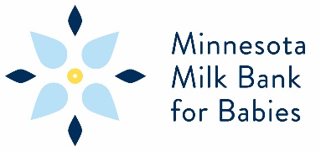
Board Membership

Minnesota Milk Bank for Babies, a nonprofit dedicated to providing safe pasteurized donor human milk to premature and medically fragile babies, seeks applicants to serve on a growing governance Board of Directors. The Milk Bank is accredited by the Human Milk Banking Association of North America and licensed by the State of Minnesota as a food manufacturer.
This is a volunteer position for a 3-year term. The Board meets virtually monthly and members may attend by phone or by Zoom. Occasional in-person meetings will be offered for strategic planning or a retreat.
Desired skills: passion for the mission and experience in such fields as development and fundraising, financial management, legal expertise, commercial real estate, marketing, communications, nonprofit programs, and clinical skills related to breastfeeding or perinatal health. We value statewide participation, diversity, and a broad range of skills and experiences. To learn more, visit www.mnmilkbank.org and see the Board of Directors tab for more information, application, and the By-laws.
If you are interested in this opportunity, please contact Jessica Longtine, Board Chair, at info@mnmilkbank.org with your statement of interest, resume, and application.

